US
UniqueSchools
Open your App CMS panel & click ‘Manage School Shop (V5)’
and ‘Add’
How To:
Add a Shop Item 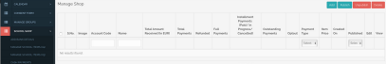
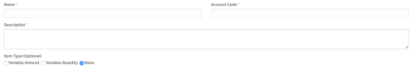
Name of your item; eg school fees Whatever nominal account you use for this type of item The description of your payment; eg school fees €150 to cover trips etc
Select the kind of payment/item which is being set up:
Variable Amount: parent can enter amount they wish to pay; eg voluntary contributions
Variable Quantity: cost is set but quantity can be specified by parent;
eg play tickets are €10 but parent can order 3 giving total of €30
None: this is a standard fee; eg item costs €5 and parent;can only pay that amount
Limit payments to a specified number:
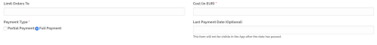
eg evening study is limited to 30 places, after 30
payments are received no other users will be able to pay and item will be removed from view for parents
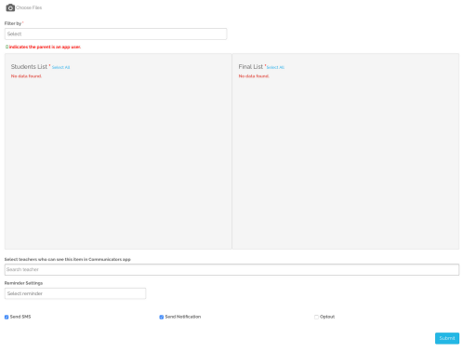
Full Payment: parent must pay in full in one transaction. Partial Payment: payment by specified instalments: eg payment of €150 over three instalments takes €50 on the first day, €50 30 days later and onward automatically until payment is complete
Option to add an image
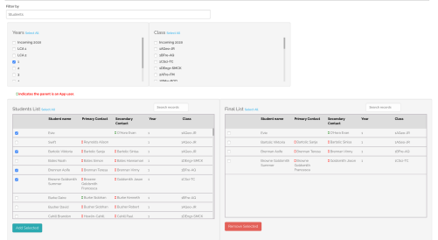
Select which Year/Class or Groups are assigned to this shop item Select which students are assigned to this shop item
Total cost of item: Please Note – if passing transaction fees onto parents these need to be added at this point. Transaction fees are 1.35% plus 31c;
eg for an item costing €10 the fee is 44c
Date item will be removed from App and parent can no longer pay
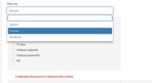
Last check to ensure you are happy with the list of students to whom you are assigning the shop item
Student 1
Primary Contact 1
Secondary Contact 1
Student 1 Student 3
Primary Contact 1 Primary Contact 3
Secondary Contact 1 Secondary Contact 3
Student 2 Student 3
Primary Contact 2 Primary Contact 3
Secondary Contact 2 Secondary Contact 3
Student 4 Primary Contact 4 Secondary Contact 4
Student 4 Primary Contact 4 Secondary Contact 4
Student 5 Primary Contact 5
Secondary Contact 5
Click ‘Add’ once you have finished your selections
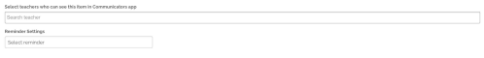
Select teachers/staff who will have access to see submitted payments in Communicators App
Set a reminder to go to parents who have not yet paid for item
Allow optout if fee is not mandatory, veg an optional
Send an SMS to non-APP users assigned to this shop item
Send notification to all App users assigned to this shop item
school trip
Submit payment details and make live in school App

